Time logging system “Loggy”
Software Architecture Description
Tautvydas Skardžius
tautvydas.skardzius@mif.stud.vu.lt
Version 1
2020-11-24

Version History

Version | Date | Author | Comments
1 | 2020-11-24 | Tautvydas Skardžius | Initial version
2 | 2020-12-07 | Tautvydas Skardžius | Added 5 views

Table of Contents
1. Version History 2
2. Table of Contents 3
3. Introduction 4
3.1 Purpose and Scope 4
3.2 Audience 4
3.3 Status 5
3.4 Architectural Design Approach 5
4. Glossary 6
5. System Stakeholders and Requirements 7
5.1 Stakeholders 7
5.2 Overview of Requirements 8
5.3 System Scenarios 10
6. Architectural Forces 11
6.1 Goals 11
6.2 Constraints 11
6.3 Architectural Principles 11
7. Architectural Views 13
7.1 Context View 13
7.2 Functional View 14
7.3 Information View 16
7.4 Concurrency View 19
7.5 Deployment View 21
7.6 Development View 23
7.7 Operational View 25
8. System Qualities 26
8.1 Performance and Scalability 26
8.2 Security 26
8.3 Availability and Resilience 26
8.4 Evolution 26
8.5 Other Qualities 27
9. Appendices 28
9.1 Appendix: Decisions and Alternatives 28
9.2 Appendix: Questions and Answers 28
9.3 Appendix: References 28
10. Instructions 29

Introduction

Purpose and Scope
Explain the purpose and scope of the document.
Primarily this is to document the architecture for the stakeholders, to ensure that it meets their goals and concerns and that the proposed architecture is correct, complete and fit for purpose.
While you should avoid presenting a lot of material available elsewhere, it may also be useful to do some or all of the following in the AD:
- summarise the project context, goals and objectives
- confirm scope and exclusions
- present an overview of goals and drivers, requirements etc
- record important decisions made and their rationale
- present alternatives considered and their reasons for rejection
- bring together other important information not captured elsewhere

What is this document for - primarily this is to document the architecture for the stakeholders, to ensure that it meets their goals and concerns and that the proposed architecture is correct, complete and fit for purpose.

Project context – currently, the company employees register their hours manually and send the spreadsheets to their managers, who, after they have already approved it, sends the spreadsheets to the accountants.

Project goals & objectives:
- Automate hour registration process
- Have employee hour registration data aggregated in one place

Audience
Define the audience of the document.
Probably the most important audience are the developers who will be designing and building the system, along with the sponsor who will be paying for it. However there are a number of other stakeholders who have an interest in the AD, as listed in the System Stakeholders and Requirements chapter. And of course the architect is a stakeholder as well.

- CEO
- Project manager
- Developers
- Maintainers
- Testers
- Employees
- Accountants
- Managers
- Administrators

Status
Explain the current status of the architecture and of this architectural description.
Is it still in progress? Being implemented? In production? You may also want to describe future plans for the document (eg will be reissued as Definitive after comments received by stakeholders).

The architecture is in planning stage. No development has been done.
Architectural description is not yet complete, stopped at context view.

Architectural Design Approach
Explain the overall architectural approach used to describe and develop the content of the document (e.g. explain viewpoints, views and perspectives). If necessary explain the architectural views that you’re using and why each is used.

?
Architekturiniai sprendimai
Skaidoma I viewus, kokie jie yra ir koks principas

Glossary

Term | Definition
Term | Definition of the term
Project dimension | Rows in which employees can log time

System Stakeholders and Requirements

Stakeholders
Define each of the key stakeholders and stakeholder groups, explaining their interest, needs and concerns for the system.
A stakeholder is anyone who has an interest in or concern about in the system documented in the AD. Consider the following stakeholder groups.
- Acquirers, who pay for the system.
- Assessors, who check for compliance.
- Communicators, who create documents and training.
- Developers, who create the system.
- Maintainers, who evolve and fix the system.
- Production Engineers, who are responsible for the deployment environment.
- Suppliers, who provide parts of the system.
- Support Staff, who help people to use the system.
- System Administrators, who keep it running.
- Testers, who verify that it works.
- Users, who have to use the system directly.
And of course the architect is also a stakeholder in the AD.

Stakeholders:
- Acquirers:
  - CEO
    - Interest - will pay for the system
    - Needs:
      - Automate employee’s time registration process
      - Have employee’s time registration data aggregated in one place
      - System should be relatively cheap to run & maintain
    - Concerns:
      - System’s development will be expensive
      - System’s maintenance will be expensive
      - System will take long to develop
- Assessors/Communicators:
  - Project manager
    - Interest – will be responsible for the creation of the system
    - Needs:
    - Concerns:
      - Created system will not satisfy stakeholder’s needs
- Developers:
  - Interest – will develop the system
  - Needs:
    - Automated CI & CD pipeline
    - Non-legacy technology stack
    - Have external logs aggregator
  - Concerns:
    - Tight budget
    - Tight schedule
    - Scope creep
- Maintainers:
  - Interest – will maintain the system
  - Needs:
    - Good project documentation
    - Automated CI & CD pipeline
    - Have external logs aggregator
  - Concerns:
    - Project will have no/poor documentation
    - Project will be “hacked up” & not been developed following the best practises
- Testers:
  - Interest – will test the system
  - Needs:
    - At least one test environment
  - Concerns:
    - There will be no test environments
- Users:
  - Employees
    - Interest - need to register hours, so the accountants know what salary to pay
    - Needs (Refer to 5.2. section)
    - Concerns
  - Accountants
    - Interest - need logged hours in this system in order to generate payslips
    - Needs (Refer to 5.2. section)
    - Concerns
  - Managers
    - Interest - will be responsible for subordinate’s time logging activities, will approve/reject them.
    - Needs (Refer to 5.2. section)
    - Concerns
  - Administrators
    - Interest - will be responsible for managing systems’ internal configuration
    - Needs (Refer to 5.2. section)
    - Concerns

Overview of Requirements
Summarise the key functional and quality property (non-functional) requirements for the system.
Functional requirements define what the system is required to do (for example, update customer name and address details). Quality properties (aka non-functional requirements) define how the system must behave at run-time or design time (for example, it must respond to requests within three seconds under a given load; it must be available 99.99% of the time; it must be possible to extend the system to meet certain types of new requirement without having to undertake a major redesign).
Avoid going into too much detail which is presented elsewhere; refer to external sources, such as requirements documents, SLAs, existing systems and so on, wherever possible. Requirements should be numbered so that you can refer to them unambiguously elsewhere.
“Ko aš tikiuosi“
Reference | Requirement Description
 | As an employee, register time in a specific group for a specific day (create time registration, e.g. 8 hours on 24th of November for paid vacation).
 | As an employee, edit/remove existing time registration
 | As an employee, comment on a specific time registration
 | As an employee, remove your own comment from time registration
 | As an employee, confirm time registrations for a specific month
 | As an employee, see registered hours, that exceed daily limit, in an different way (marked red)
 | As an employee, see public holiday days in a different way (marked grey)
 | As an employee, select my manager
 | As an employee, select working hours per week (20h, 30h, 40h)
 | As an accountant, export all the employee time registrations for the selected month in selected format
 | As an accountant, view all employees hour registrations
 | As a manager, view all subordinates time registrations
 | As a manager, comment on subordinate’s time registrations
 | As a manager, remove your own comment from subordinate’s time registration
 | As a manager, approve/reject subordinates time confirmation for a specific month
 | As an administrator, manage managers list (add/remove available managers)

Reference | Requirement Description
NFR1. | System must be available 99.9% of the time
NFR2. | System must respond within 5s. when under any load

System Scenarios
List, and briefly outline the most important scenarios that matter to the key stakeholders and/or can be used to illustrate the system’s ability to meet its most important requirements.
A scenario describes a situation that the system is likely to face in its production environment, along with the responses required of the system. You should consider both functional scenarios (things that the system must do usually in response to an external event or input) and system quality scenarios (how the system should react to a change in its environment, such as an increase in workload).
In most cases the scenarios take a significant amount of space and it is often appropriate to record them in a separate document to avoid the AD getting too large.

Functional Scenarios
Functional scenarios model things that the system must do response to an external stimulus (eg an event or input).
“kaip vyksta: ko aš tikiuosi” visas flow
Scenario Reference | S1.
Overview | Notify employees, that have not confirmed their time for the month, on the last month’s working day to confirm their time
System State
System Environment | Last working day of the calendar month
External Stimulus | Internal background job running, that checks for employees, which have not confirmed their time yet
Required System Response | Send a reminder email to every employee that has not confirmed their time

System Quality Scenarios
System quality scenarios model how the system should react to a change in its environment (such as an increase in workload or a security breach).
“uzregistruoti 10k vartotoju per valanda” kiekybinai reikalavimai labiau

Situs du raudonus trinti lauk
Scenario Reference | SQ1.
Overview | Increased system load
System Environment | Production environment
Environment Changes | CPU load exceeds 75% for 1 minute
Required System Behaviour | Scale horizontally, by creating new instances

Scenario Reference | SQ2.
Overview | Decreased system load
System Environment | Production environment
Environment Changes | CPU load is lower than 25% for 1 minute and have more multiple instances running
Required System Behaviour | Downscale by shutting down excessive instances.

Architectural Forces

Goals
List the main architectural goals and business drivers for the project.
A goal is something that the project wants to make happen (eg to simplify the customer management processes) while a business driver is some external force which shapes the project (eg the level of customer complaints is increasing).
Ask yourself questions like the following: What are the key targets that you are setting yourself as the architect? Do you aim to reuse existing software? Or develop the system at minimum cost? Or are you aiming for very high reliability? Or … ?

Use of existing software - no reuse of existing software – system will be built from scratch.

Goals:
- High reliability
- Moderate cost
- Moderate development time

Constraints
List the main architectural constraints that the project must respect.
A constraint is something that limits your architectural choices: for example, the project must be completed by Christmas, it must be implemented in Java, or it must conform to a certain operational model.
You should also refer to any specific standards or regulation which govern the architecture.

GDPR

Architectural Principles
Explain the architectural design principles which have shaped the architecture.
A principle is a fundamental statement of belief, approach, or intent that guides the definition of the architecture. It may refer to current circumstances or a desired future state. A good principle is constructive, reasoned, well-articulated, testable and significant.
Each principle should be justified by a rationale and may be supplemented by some implications. For example, a principle on the use of open standards may have as its rationale the drive for interoperability, and as an implication the need to assess and agree the appropriate standards which apply to each component.
You may also choose to include more specific principles in the Views chapter.
Principle Reference | (unique number)
Principle Statement | (brief statement of the principle)
Rationale
Implications
Further Information

Architectural Views

Context View
The context view of the system describes the relationships, dependencies and interactions between the system and its environment (the people, systems and external entities that it interacts with).

Context Diagram

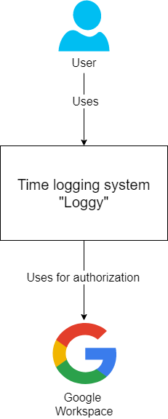

Functional View
The functional view of the system defines the system’s architecturally significant functional elements, the responsibilities of each, the interfaces they offer and the dependencies between elements.
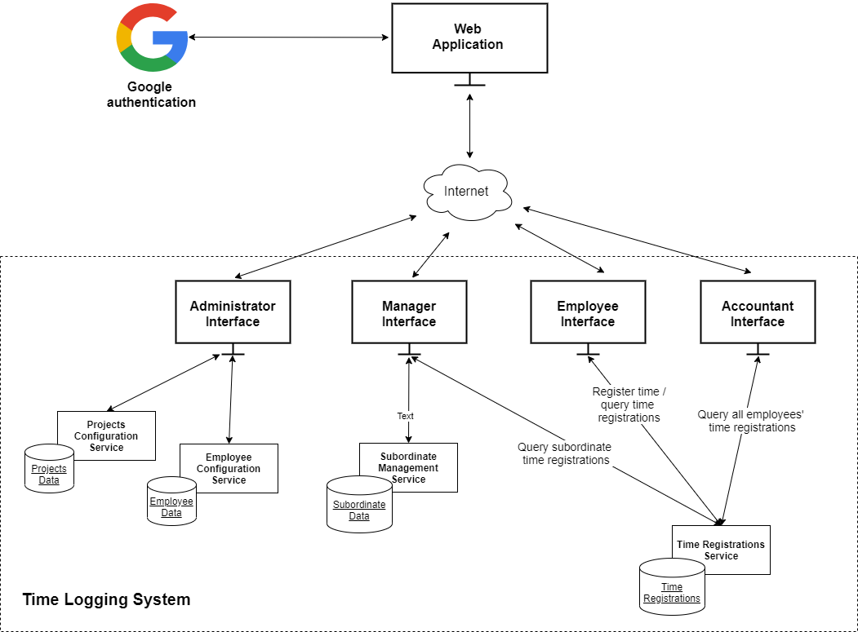

Functional Elements

Element Name | Time Registrations Service
Responsibilities | - Query time registrations  - Update time registrations  - Delete time registrations  - Confirm timesheet  - Comment on time registration
Interfaces – Inbound | - Employee interface  - Manager interface  - Accountant interface
Interfaces – Outbound | SQL server

Element Name | Subordinate Management Service
Responsibilities | - Approve submitted time sheet  - Reject submitted time sheet
Interfaces – Inbound | Manager interface
Interfaces – Outbound | SQL server

Element Name | Employee configuration Service
Responsibilities | - Manage managers list  - Manage user’s roles
Interfaces – Inbound | Administrator interface
Interfaces – Outbound | SQL server

Element Name | Projects configuration Service
Responsibilities | - Manage projects list  - Manage project dimensions list
Interfaces – Inbound | Administrator interface
Interfaces – Outbound | SQL server

Information View
The Information view of the system defines the structure of the system’s stored and transient information (e.g. databases and message schemas) and how related aspects such as information ownership, flow, currency, latency and retention will be addressed.

Data Structure
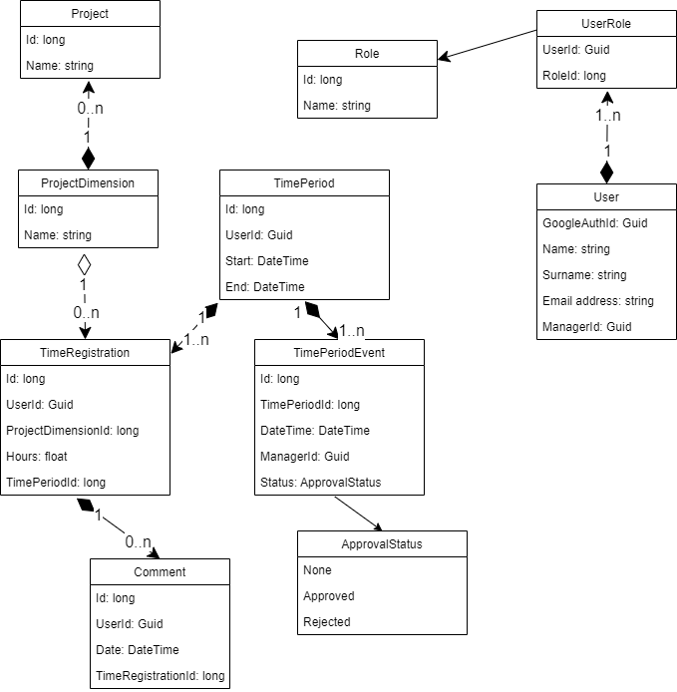
Figure 1. System Data Structure

Data Flow
If it is not clear from the functional view’s interaction diagrams, define how data flows through the system from one component to another and to external components.
As with the data structure diagram, keep this simple and focus on no more than about 10-15 key functional elements. Don’t try and illustrate every data flow here or your readers will get lost in the detail.
An example is shown below using a data flow diagram.
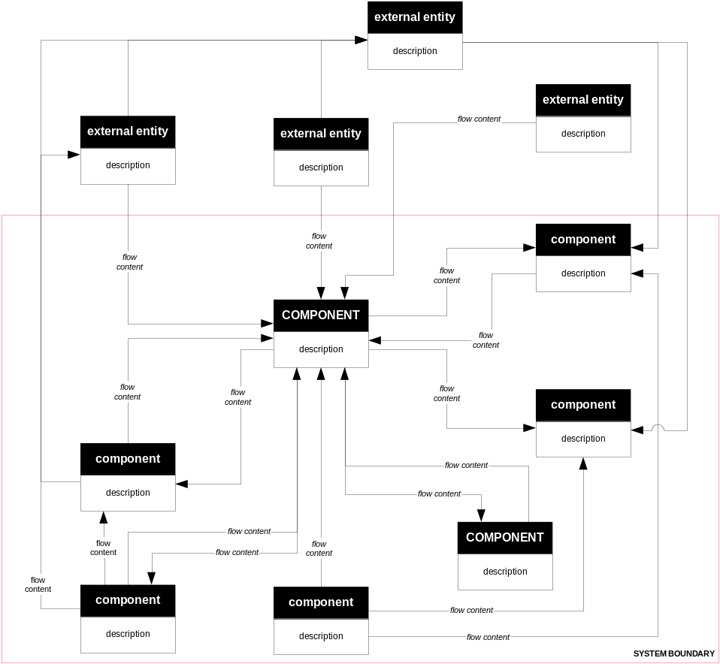
Figure 2. System Data Flow

Data Ownership
If data is owned by more than one entity or part of the system, define who owns which pieces of the data and explain how any resulting problems will be handled.
In the example below, it can be seen that there are issues with entity 4 which can be updated by System D which is not the owner. The AD should explain how this inconsistency will be managed.
Entity | System A | System B | System C | System D
entity 1 | MASTER | r/o copy | reader | reader
entity 2 | reader | MASTER | none | reader
entity 3 | none | reader | MASTER | reader
entity 4 | MASTER | none | none | reader  updater  deleter

Information Lifecycles
If key entities have complicated lifecycles then model the way that their state changes over time.
Focus on a few key entities whose transitions help to illuminate key features of the architecture, rather than just created/updated/updated/updated/destroyed.
There are two common techniques for modelling information lifecycles, entity life histories and state transition diagrams. Both are useful; choose one style and stick to it throughout the AD.
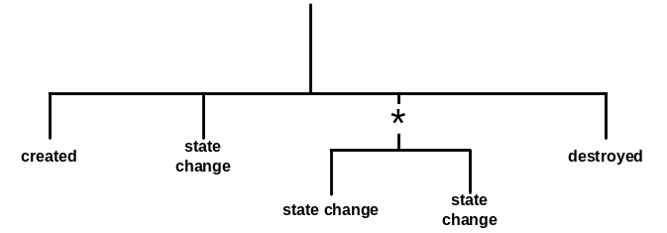
Figure 3. Entity Life History
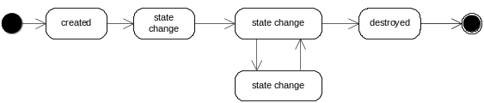
Figure 4. State Transition

Timeliness and Latency
If information needs to be copied around the system or is updated regularly, explain how timeliness and latency requirements will be addressed.

Archive and Retention
Explain how will archive and retention requirements will be met by the system.

Concurrency View
The Concurrency view of the system defines the set of runtime system elements (such as operating system processes) into which the system’s functional elements are packaged.
If the concurrency structure is complicated or it isn’t obvious from the information in the other views, define how functional elements will be packaged into processes and threads and explain how they interact safely and reliably using suitable inter-process communication mechanisms. This can be achieved via a UML model (using stereotypes), by using a special purpose concurrency modelling language, or by creating an informal notation for the situation at hand.

Concurrency Model
Model the processes, process groups and threads, and the interprocess communication channels between them.
You may also choose to model the mechanisms used to protect the integrity of data and other resources shared between concurrent execution units, such as mutexes or semaphores.
You can use a UML component model to represent the information graphically, stereotyping the components appropriately.
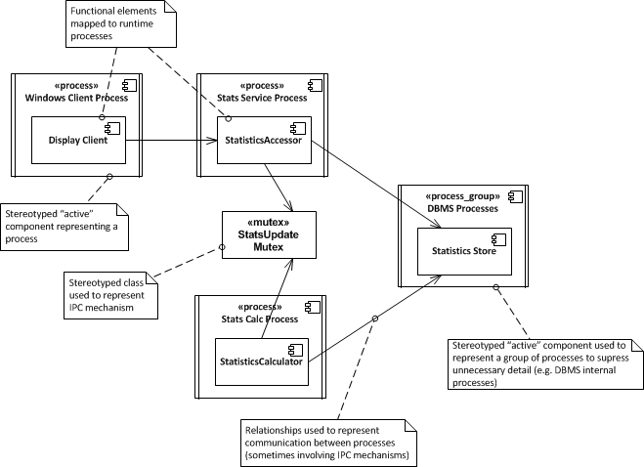
Figure 5. Concurrency Model

State Model
Model the states that the systems runtime elements can be in, the transitions between those states and the events which drive those transitions.
A state is an identified, named stable condition which occurs during the system’s runtime. An event is something that happens which causes an element to undergo a transition from one state to another. Actions may also be associated with transitions, so that while the element changes state, the action is performed.
Focus on a few key elements whose states and transitions help to illuminate key features of the architecture.
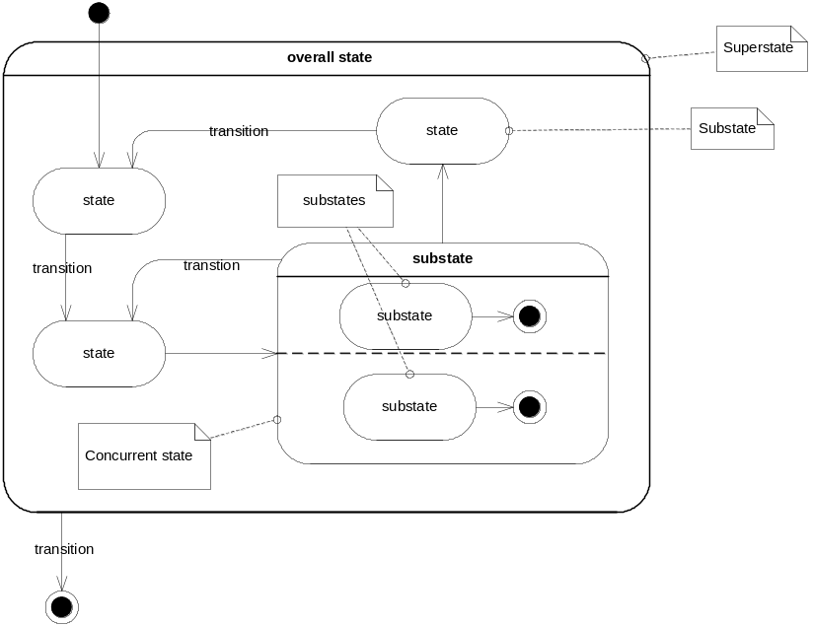
Figure 6. State Model

Deployment View
The Deployment view of the system defines the important characteristics of the system’s operational deployment environment. This view includes the details of the processing nodes that the system requires for its installation (i.e. its runtime platform), the software dependencies on each node (such as required libraries) and details of the underlying network that the system will require.

Runtime Platform Model
Show the system’s runtime platform (defining nodes, links and the mapping of functional elements or processes to nodes).
You can use a UML deployment diagram here, or a simpler boxes-and-lines diagram.
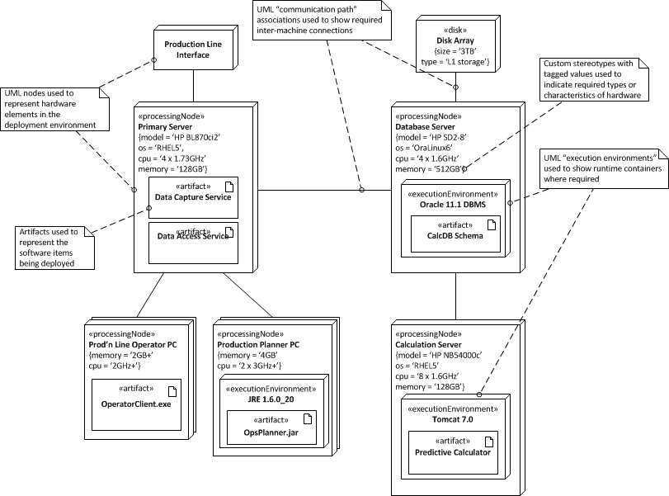
Figure 7. Deployment Model
It is often useful to explicitly map the functional elements onto the nodes that they will be running on, particularly if the deployment model is complex or the mappings aren’t obvious.
Functional Element | Deployment Node(s)
element | node(s)
element | node(s)

Software Dependencies
Define the software that will be required on the various types of node in the runtime platform model, in order to support the system (such as operating system , system software or library requirements). Where versions are known you should state these. Clearly state any known version dependencies (eg component A requires at least version X of component B).
This can usually be presented in tabular form.

Network Model
If network requirements are complex, include a network model that illustrates the nodes, links and network hardware that the system requires, making quality of service requirements clear.

Development View
The Development view of the system defines any constraints on the software development process that are required by the architecture. This includes the system’s module organisation, common processing that all modules must implement, any required standardisation of design, coding and testing and the organisation of the system’s codeline.
Much of the information in this view is normally presented at a summary level, with more detail being available in other developer focused documents such as a development standards document. However you may still need to record some architecturally significant decisions at this stage, for example around choice of libraries or frameworks, or approach and tools for software deployment or configuration management.

Module Structure
Use a model that defines the code modules that will be created and the dependencies between them. A UML package diagram is often an effective way to achieve this.
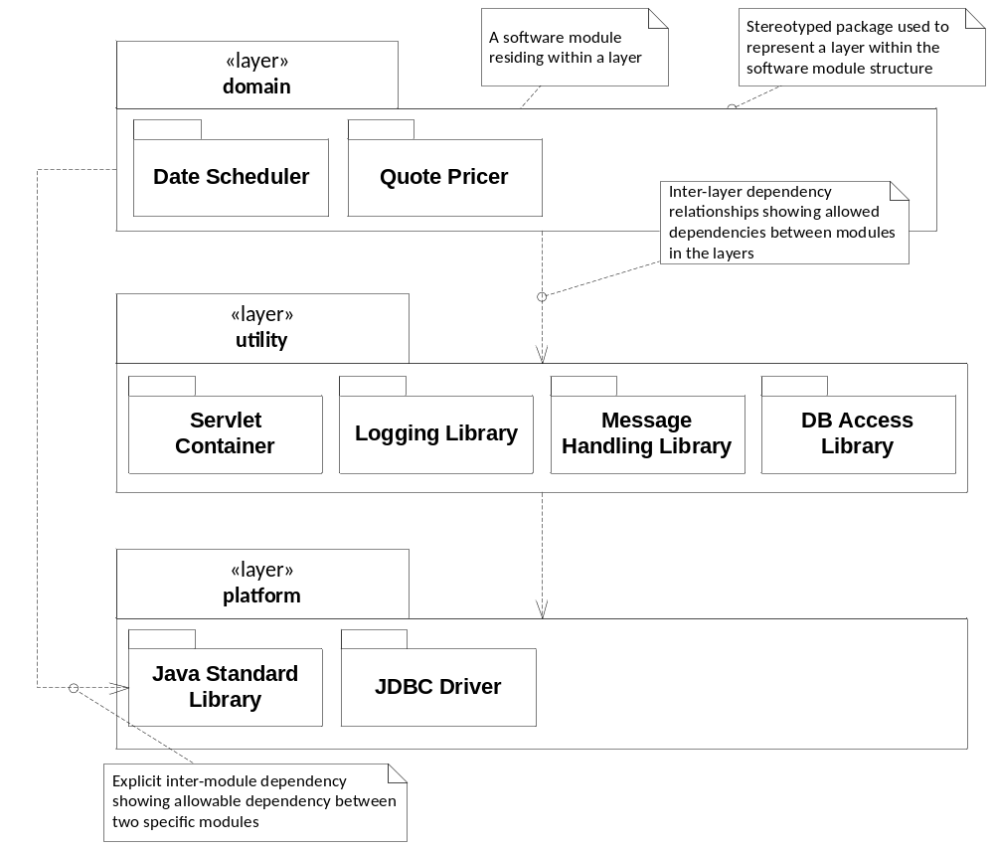
Figure 8. Module Structure Diagram

Common Design
Define the common design (such as logging, security, tracing and so on) that must be performed in a standard way across the system and how it should be performed (e.g. via a design pattern or reference to a code library or sample).

Standards for Design, Code and Test
Define any standards that must be followed for design, code and unit testing, probably by reference to an external document.

Codeline Organisation
Define the codeline structure (i.e. how the source code will be held as a directory hierarchy and how it will be built into deliverable software). Define the directory hierarchy, build tools and delivery tools (such as testing or continual integration tools) that will be used to deliver the software for testing and production.

Operational View
The Operational view defines how the system will be installed into its production environment, how data and users will be migrated to it and how it will be configured, managed, monitored, controlled and supported once this is achieved. The aim of the information in this view is to show how the operational environment is to be created and maintained, rather than to define detailed instructions or procedures.

Installation and Migration
Define the high-level steps required to install the system and any specific or unusual requirements for it.
If parallel running of old and new systems is required, explain how this will be done without disrupting existing systems, and the transition states required.

Operational Configuration Management
Define the main groups of operational configuration items and common sets of values for them (e.g. batch and overnight sets) and explain how these groups will be managed in the production environment.

System Administration
Explain the requirements the system places on the systems administrators (in both routine and exceptional situations) and the facilities that the system will provide or rely on in the operational environment.

Provision of Support
Define the groups involved in providing support for the system and the roles and responsibilities of each (including escalation procedures if relevant).

System Qualities
This section explains how the architecture presented meets its each of its required system quality properties.
While much of this information will be intrinsic to the views documented in the previous chapter, it is often useful to bring out some of it separately. In particular, if a quality property such as security or performance depends on features documented in several different views, then you should explain this here. For example, scalability may depend on optimisations in the data model (documented in the Information View) along with load balancing components (documented in the Deployment View).

Performance and Scalability
For each of the main performance and scalability requirements, explain how the system will meet the requirement. Refer to practical testing and performance modelling work that has been performed as part of applying this perspective.
Requirement | How Met
1. average user response time should be XX under load YY | refer to performance modelling spreadsheet

Security
For each of the main, security requirements, explain how the system will meet the requirement. Define (or reference) the threat model, security policy and security design that have been used as part of applying this perspective.
Requirement | How Met
1. all users must be authenticated before being allowed to access the system | access to all screens is via standard login screen with passwords synchronised overnight to central LDAP service

Availability and Resilience
Explain the A&R requirements.
Define the availability schedule(s) for the system.
Explain how the system will meet the requirements, referring to practical testing, modelling and design work that has been performed as part of applying this perspective.
Requirement | How Met
1. There should be no single point of failure | all deployment nodes are clustered or load-balanced; where nodes are clustered, component failure is detected automatically and the passive node is brought up automatically

Evolution
Explain the evolution requirements.
Define the evolutionary dimensions that are relevant to the system.
Explain how the system will meet the requirements, taking into account the likelihood of each type of evolution occurring (explaining how the probabilities were arrived at) and referring to the design work performed as part of applying his perspective.
Requirement | How Met
1. it must be possible to add extra input channels without having to redesign the core system | input channel components are loosely coupled to central processing modules via standardises abstract interface

Other Qualities

Accessibility
Explain how the system meets any accessibility requirements (if any).

Internationalisation
Explain how the system meets any internationalisation (or localisation) requirements (if any).

Location
Explain how the system meets any requirements for the geographical location(s) it is to be installed in (if any).

Regulation
Explain how the system meets any regulatory requirements (if any).

Usability
Explain how the system meets any usability requirements (if any).

Appendices

Appendix: Decisions and Alternatives
Explain the primary architectural design decisions that have been made, their rationale and the set of alternatives considered for each.

Appendix: Questions and Answers
As you develop your architecture and explain it to people, the same questions are probably going to be asked repeatedly. In some cases, this is a signal to improve one particular part of the architectural description, but in others there is no one place that can address the query, so answer these questions here.
It is also sometimes the case that there are questions that you want readers to ask themselves in order to ensure that they have understood the architecture and its implications and a good way of encouraging this is also to put an appropriate question and answer in this section.

Appendix: References
List the references that you use throughout the text to allow them to be cited and located. For example:
- Software Systems Architecture: Working with Stakeholders Using Viewpoints and Perspectives, 2nd Edition. Nick Rozanski and Eoin Woods, Addison Wesley, 2011.

Instructions
This template provides an outline for a view-based software architecture description document, of the style suggested by the approach in the book Software Systems Architecture, 2nd Edition by Nick Rozanski and Eoin Woods (Addison Wesley, 2011).
The text in this style is all instruction text, which you should remove as you write the document. Once you have done this, the template is essentially a set of headings and some pro-forma text.
This template is a superset of the content of a typical AD. If there are sections of the template that are not relevant to your project then you should probably omit them. Similarly if there are topics that are important to your system but not part of the template, then you should add appropriate sections to it.
For more information about the architectural approach underpinning the template, the concepts presented and the techniques used to create effective architectural descriptions, see the web site http://www.viewpoints-and-perspectives.info.

